Standard Operating Procedure (SOP) for Checking Azure Firewall Logs
1. Purpose:
- To provide a standardized method for accessing and reviewing Azure Firewall logs to ensure network security and troubleshoot issues.
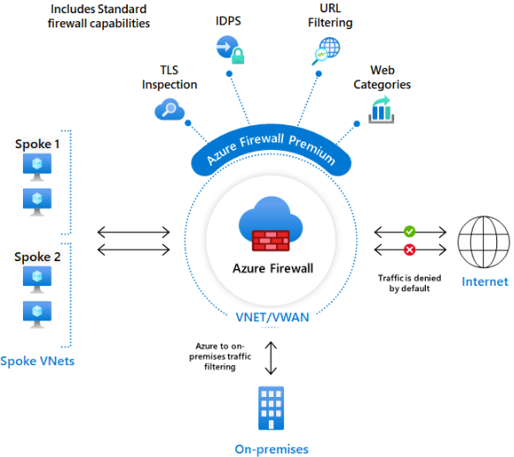

2. Scope:
- This procedure applies to all IT personnel responsible for network security and monitoring within the organization.
3. Prerequisites:
- Access to the Azure portal.
- Appropriate permissions to view Azure Firewall logs.
- Basic understanding of Azure Firewall and network security principles.
4. Procedure:
Step 1: Access the Azure Portal
- Open your web browser and navigate to the Azure Portal.
- Log in with your credentials.
Step 2: Navigate to Azure Firewall
- In the Azure Portal, use the search bar to find “Azure Firewall”.
- Select your Azure Firewall instance from the list.
Step 3: Access Logs
- In the Azure Firewall instance, go to the “Logs” section.
- You can find this under the “Monitoring” category in the left-hand menu.
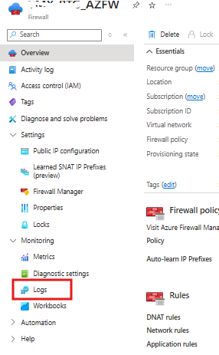
Step 4: Query Logs Using Azure Monitor
- Click on “Logs” to open Azure Monitor Logs.
- Use Kusto Query Language (KQL) to query the logs.
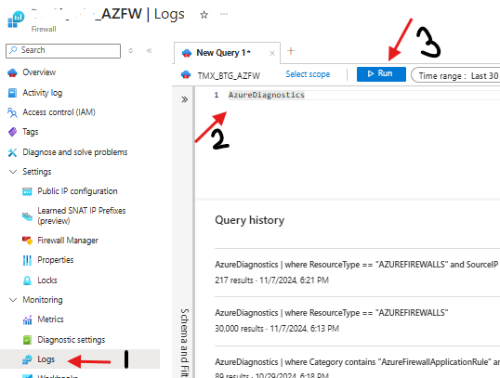

Here are some example queries:
  - To view all logs:
AzureDiagnostics
| where ResourceType == "AZUREFIREWALLS"
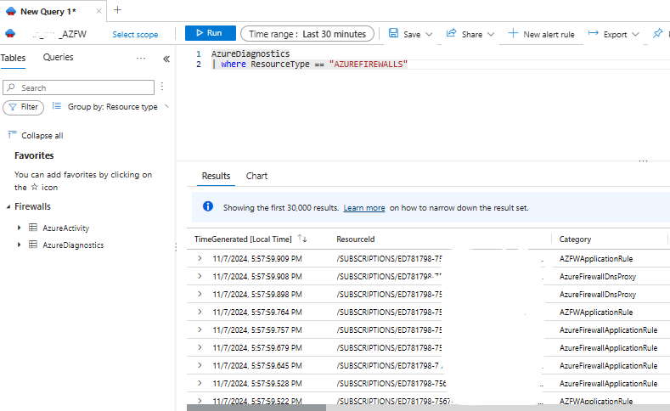
  - To find logs with specific IP addresses:
AzureDiagnostics
| where ResourceType == "AZUREFIREWALLS"
| where SourceIP == "x.x.x.x"
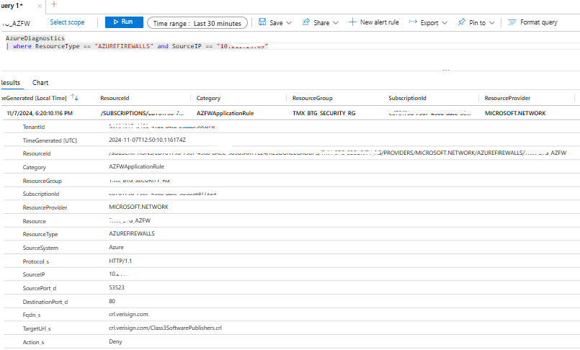
Step 5: Analyse and Export Logs
- Review the queried logs for any anomalies or issues.
- Use the export feature to download logs in CSV format if needed for further analysis or reporting.

Thank You

